Virtec Instruments, USA
Ultrasonic Flowmeter – Installation & Operating Manual
Edition: 2021/Part-B

Welcome Note
Thank you for choosing Virtec Instruments, USA — a trusted name in advanced metering technology. This manual provides comprehensive guidance on the installation, commissioning, operation, and maintenance of our Ultrasonic Flowmeter range.
Our flowmeters are engineered for accuracy, durability, and performance, designed to meet the needs of both utility and industrial applications.

Important Notice
The following pages include detailed instructions on:
- Introduction to Virtec Instruments.
- Product overview and specifications.
- Installation requirements and best practices.
- Configuration and commissioning procedures.
Please read the entire manual before beginning installation or operation to ensure correct handling and optimal performance of the device.
For further assistance, contact our technical support team at sales@virtec.us.

Introduction
Virtec Instruments is a trusted name in precision measurement and smart metering technologies, specializing in high-performance flow and thermal energy solutions. With a commitment to innovation, quality, and customer satisfaction, Virtec delivers advanced instrumentation that meets the demanding needs of water, HVAC, industrial, and energy management sectors.

Ultrasonic Flowmeters
Designed for accuracy and reliability, Virtec ultrasonic flowmeters offer non-intrusive, maintenance-free flow measurement for a wide range of conductive and non-conductive fluids. Utilizing transit-time and Doppler technologies, these meters provide high-resolution data with minimal pressure drop, ideal for water distribution, building automation, and industrial process monitoring.

Ultrasonic Heat Meters
Virtec ultrasonic heat meters are engineered to deliver precise thermal energy measurements in heating and cooling systems. These meters are compliant with MID EN1434 standards and provide long-term stability, low starting flow, and robust data communication capabilities—making them an essential component in smart energy management for residential, commercial, and district energy systems.

Working Principles
Ultrasonic flowmeters operate based on the transit-time difference principle. Two ultrasonic sensors are placed at an angle to the flow path—one upstream and one downstream. As fluid flows through the pipe, it causes a time difference between the upstream and downstream signals. This time difference is directly proportional to the flow velocity of the fluid. Since there are no moving parts and no direct contact with the fluid, these meters are highly durable and well-suited for clean liquid applications with minimal maintenance.
Alternatively, in some conditions, Doppler-based ultrasonic flowmeters are used, especially when the fluid contains suspended particles or gas bubbles. In this method, an ultrasonic signal is transmitted into the flow, and the frequency shift (Doppler effect) of the reflected signal is used to calculate the flow velocity. This technique enables reliable flow measurement in partially contaminated or aerated liquids.

Why Virtec Instruments?
- Proven technology with high measurement accuracy
- Durable, low-maintenance designs suited for diverse environments.
- Integration-ready with MODBUS, BACnet, M-Bus, and other protocols
- Backed by technical support, calibration services, and application expertise.
With a growing footprint across Asia, Europe, and the Middle East, Virtec Instruments is committed to driving smarter, more sustainable flow and energy measurement solutions. Partner with us to experience performance you can measure—and trust.

Virtec Energy Meter Instruction Manual
This instruction manual provides essential information for the use and operation of your flow meter. It is important to read the reference manual carefully before beginning any operations to ensure optimal performance of your portable ultrasonic flow meter.

Operation and Precautions
Improper operation can affect the normal functioning of the flow meter, reduce its service life, or cause malfunctions. Following the guidelines in this manual will help maintain the device's longevity and reliability.

Manual Overview
This manual presents step-by-step instructions for using the flow meter. It begins with details on the product components, then covers installation, wiring, quick settings, and more, making the operation process straightforward and accessible.

Advanced Settings and Functions
By exploring the menu settings, users can access the powerful functional options and output features of the flow meter, enabling the device to meet higher application requirements.

Inspection Before Installation
Inspection should be made before installing the flow meter. Check to see if the spare parts are in accordance with the packing list. Make sure there is no potential damage to the enclosure due to a loose screw or loose wire that may have occurred during transportation. If you have any questions, please contact your representative as soon as possible.

General Safety Precautions
• Always follow the manufacturer’s installation and operation manual.
• Ensure that only qualified personnel handle the installation, maintenance, or troubleshooting of the flow meter.
• Disconnect electrical power and isolate hydraulic lines before performing any installation or service.
• Wear personal protective equipment (PPE) such as gloves, safety goggles, and protective footwear.

Compliance Standards
• ISO 4064 / EN 1434: For volumetric and thermal energy measurement.
• ASHRAE Guidelines: For HVAC metering standards and performance evaluation.
• CE / UL Certification: Ensure flow meters meet relevant electrical and safety certifications.
• BIS / IS Standards (India-specific): Adhere to Bureau of Indian Standards norms for flow metering and instrumentation.

Handling and Lifting Precautions
• Always lift the meter using the designated lifting lugs or brackets.
• Avoid using the sensor cables or pipe connections as lifting points.
• Use appropriate lifting equipment (slings, chains, hoists) rated for the weight of the flow meter.
• Ensure that the meter is balanced during lifting to avoid tipping or damage.

Installation Precautions
• Straight Pipe Lengths: Ensure minimum straight pipe lengths upstream and downstream (usually 10–20 times the pipe diameter) for accurate readings.
• Flow Direction: Follow the arrow marking on the meter to match the direction of water flow.
• Vibration Control: Mount the flow meter away from sources of excessive vibration and use anti-vibration supports if necessary.
• Positioning: Install the flow meter in a horizontal or vertical pipe run based on manufacturer recommendations. Avoid air pockets and cavitation areas.
• Isolation Valves: Install shut-off valves upstream and downstream of the meter for maintenance without system shutdown.
• Grounding: Properly ground the flow meter to protect against electrical interference.
• Environmental Protection: If installed outdoors, ensure proper housing or weatherproof enclosures.

Post-Installation Checks
• Check for leaks at all joints and flanges.
• Verify that the meter display or output is functioning correctly.
• Calibrate the meter if required before commissioning.
• Ensure compliance documentation is complete and retained for audits.

Product Series Information
Transmitters in the VIR-832 series operate on 230V AC, while the VIR-832-M series operates on 24V DC. All functionality and features remain the same across both series.
Electronic Flow Transmitter: VIR 832M/VIR 832

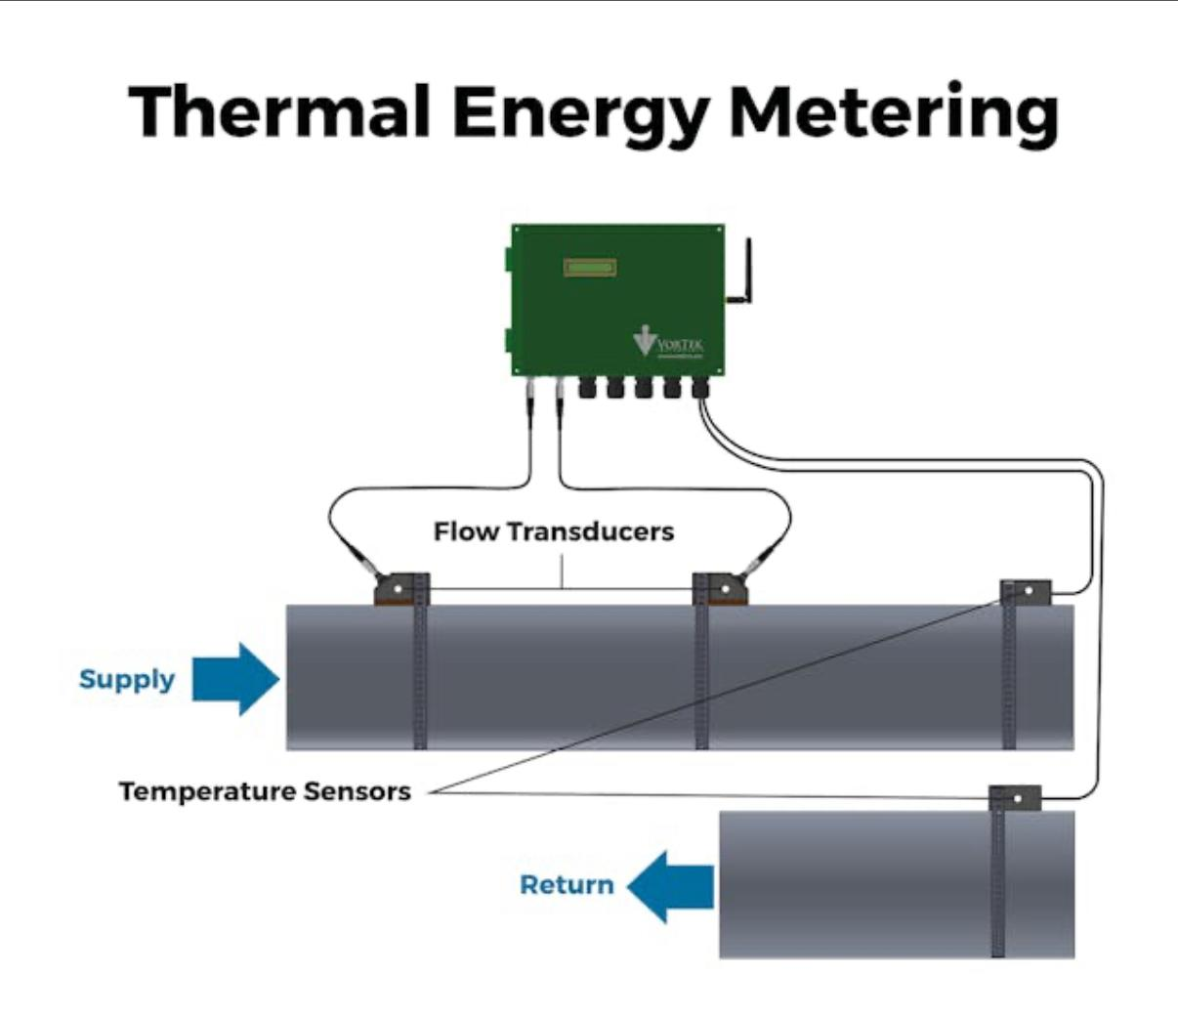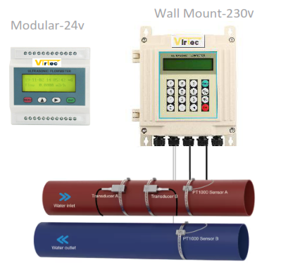

Transducer Installation Guidelines

Preparing the Pipe Surface
Before installing transducers, ensure the pipe surface is thoroughly cleaned. Remove any rust, scale, or loose paint to create a smooth area for mounting.

Selecting and Preparing the Installation Site
Choose a section of the pipe suitable for sound conduction. Apply a generous band of sonic coupling compound to the centre of each transducer face and to the prepared pipe surface.

Attaching the Transducers
Mount the transducers using the provided racks, securing them tightly to the pipe. The transducers should be installed at the pipe's centre line on horizontal pipelines, and their installation direction must remain parallel to the flow.

Installation Considerations
Ensure no air bubbles or particles are present between the transducer and the pipe surface. For horizontal pipes, install the transducers at the 3 o’clock and 9 o’clock positions to avoid air bubbles accumulating at the top. If symmetrical horizontal installation is not possible, install the transducers at a location where the pipe remains full of liquid.

Transducer Spacing
After entering all required parameters, reference the standard spacing between the tops of the two transducers, as indicated in the "Setup Menu - Pipe parameter." Reserve this spacing during installation.

Transducer Mounting Methods
There are four available mounting methods: V, Z, N, and W. Details as under:
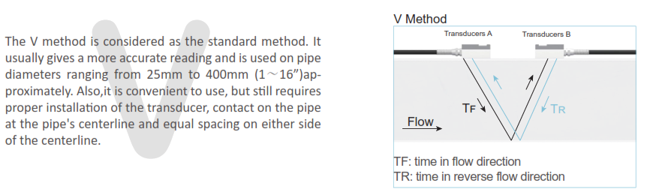
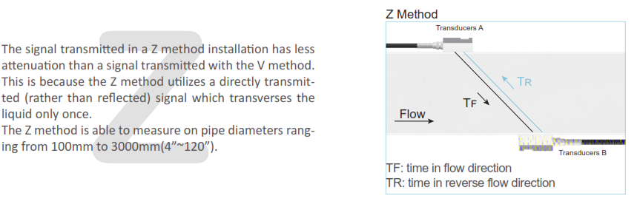
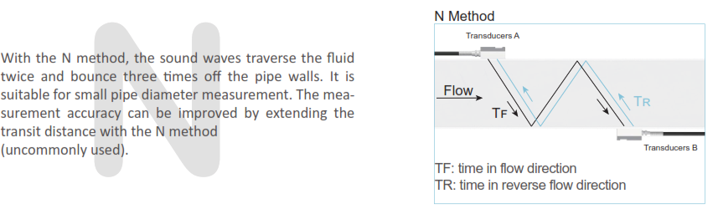
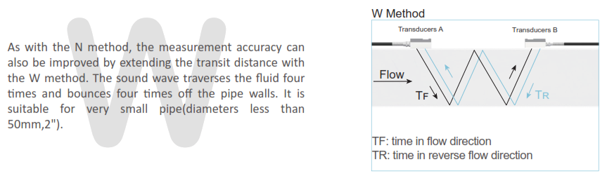
Clamp-On Transducer Installation
Pre-Installation Checklist
Before installation, confirm the pipeline and liquid parameters to ensure accurate setup.
Step-by-Step Installation Procedure
- Select the appropriate installation method.
- Input the required measurement parameters.
- Clean the surface of the pipe thoroughly.
- Install the transducers securely.
- Verify and check the installation for accuracy.
Choosing the Installation Method
There are two primary methods for mounting clamp-on transducers: the V-method and the Z-method.
- V-method: Recommended for pipe sizes ranging from DN15 to DN700. In this configuration, the pair of transducers should be aligned horizontally, with their central lines running parallel to the axis of the pipeline.
- Ensure pair of transducers in A & B point has horizontal alignment, the central line in parallel with the pipeline axis and equal to distance shown the VIR-832 transmitter menu 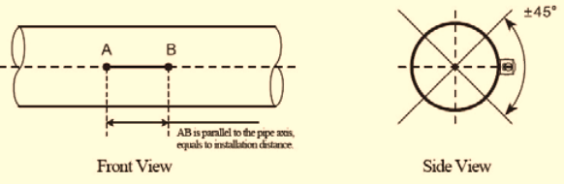
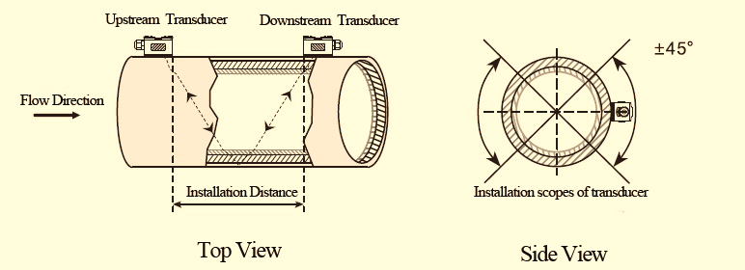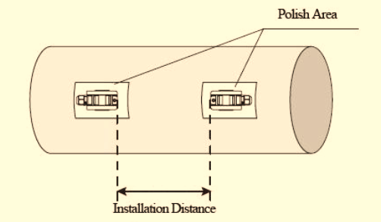
Mark the Distance. Polish the surface removing any extra layer on pipe. Apply Silicone gel supplied along with detectors and place on pipe on the marked point. Use a steel belt or rope and tighten the detectors

Insertion Type Installation Guidelines

Mounting Position and Preparation
Select the desired mounting position on the pipe and weld a mounting seat at that location. Next, create an appropriate hole using drill tools. Once prepared, insert the wetted transducer into the mounting hole and tighten it securely.

Installation Notes for Transducers
The two transducers should be installed at the pipe's centreline when working with a horizontal pipeline. Ensure that the installation direction of each transducer is parallel to the direction of flow. On horizontal pipes, install the transducers in the 3 o’clock and 9 o’clock positions along the pipe section. This placement helps to avoid air bubbles accumulating in the pipe’s upper section.
If symmetrical horizontal installation is not possible due to site limitations, select a location that ensures the pipe remains completely full of liquid.

Tools and Accessories (for Insertion type transducer)
During installation, appropriate mounting tools are required. HD35-specific drill tools can be used for pressure positioning and drilling. For carbon steel pipes, direct welding is possible. For stainless steel pipes, order a stainless-steel mounting seat and perform suitable welding.
For cast iron, fiberglass, PVC, and cement pipes, special saddles must be ordered for installation. Accurate measurement of the pipe’s outer diameter is essential to prevent leakage.

Transducer Spacing
Ensure correct spacing between transducers as specified for optimal operation. Pl refer to Menu /parameters for details.

Transducer Installation Procedure (Horizontal Pipe, V Method)

Step 1: Marking Installation Points
- Based on the transducer spacing recommended by the flow meter, identify the optimal installation locations at the 3 o’clock and 9 o’clock positions on the pipe.
- Prepare a piece of rectangular tape, marking an “indicator line” approximately 100 mm from one edge. This serves as a reference for alignment. Ensure straight line requirement.
100mm
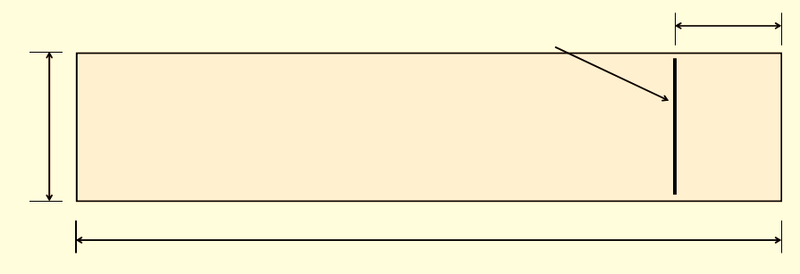

Step 2: Aligning with Pipe Axis
- Wrap the tape around the pipe so the edges meet cleanly, ensuring the indicator line remains parallel to the pipe’s axis. Use the extended indicator line to mark a straight reference along the pipe surface.

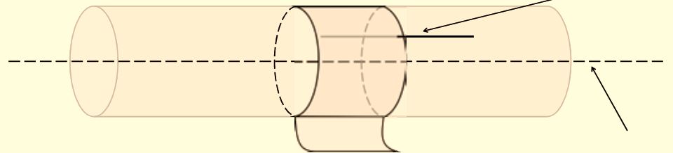

Step 3: Transferring and Extending Reference Marks
- Remove the tape and use the extended indicator line as a guide to transfer a straight line in the reverse direction along the pipe.
- According to the specified transducer spacing, mark two points (A and B) along this line. These marks represent the centre points for the welding mounts.
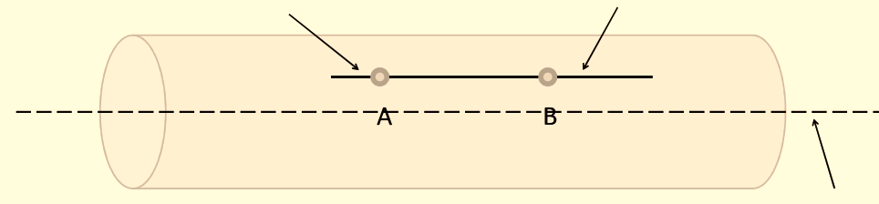

Step 4: Welding and Valve Installation
Engage qualified welding personnel to weld the mounting base onto the pipe. Once secure, install the brass ball valve onto the welded base. Open the ball valve and insert the HD35 hole drill as illustrated. The HD35 hole drill is designed for use with standard impact or electric drills equipped with round-head handles. After drilling completely through the pipe wall, remove the drill, close the ball valve, and detach the HD35 drill. This completes the pressurized opening procedure.
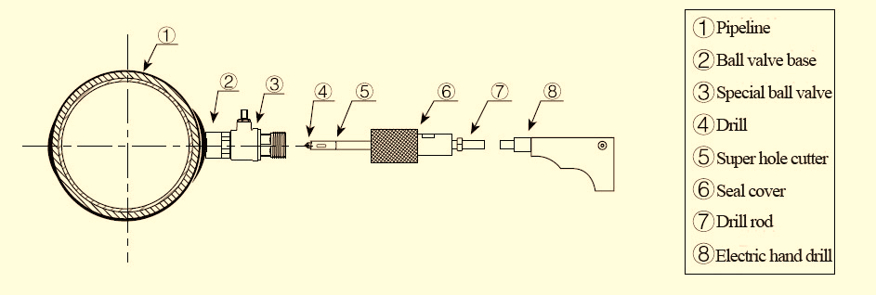

Step 5: Transducer Installation and Depth Adjustment
With the base prepared, install the transducer. Adjust its insertion depth based on the calculated pipe wall thickness to determine the correct "h value" (see diagram for reference). The transducer should indicate the direction to the outside, as shown in the corresponding illustration.
Note: The transducer indicates the direction to the outside, as shown below.

Positioning of parallel insertion transducer need to meet the 3 factors as follow:
- Installation distance = Vertical distance of two transducers along the pipe axis direction
- Make sure two transducers are in the same horizontal line,
- Insertion depth = 1/3 inner diameter

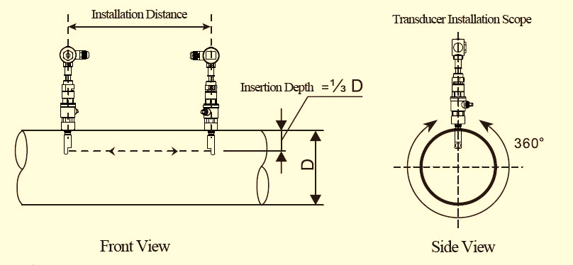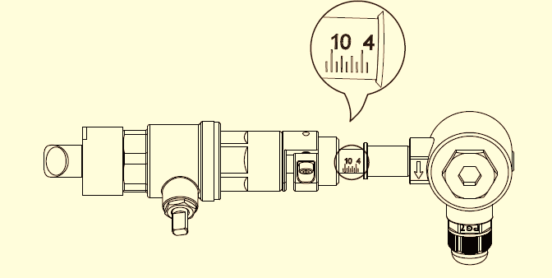

Insertion Depth Adjustment: Adjust the depth scale according to pipe wall thickness and completely push in the transducer rod. Adjust the proper insertion depth and transmit direction to get good ultrasound signal.

Installation Check-Clamp On & Insertion Transducers
To guarantee reliable operation, the flow meter is equipped with diagnostic functions to evaluate signal strength, signal quality, and transmission timing.

Signal Strength and Quality (M90)
- Signal Strength: Displayed on a scale from 00.0 (no signal) to 99.9 (maximum signal). For proper functioning, a value above 60.0 is recommended. - Signal Quality (Q value): Indicated from 00 (worst) to 99 (best). A Q value above 60 ensures the flow meter can operate accurately.
During installation, adjust the transducers to maximize both signal strength and quality. Achieving higher values in these metrics helps ensure long-term stability and precise measurement.
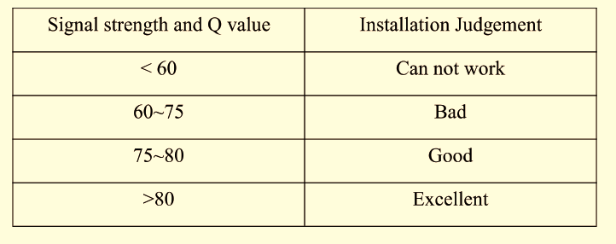

Common checking for Clamp on and Insertion type Transducers-Transmission Time Ratio (M91)
- The transmission time ratio compares the theoretical transmission time with the measured value and is displayed as a percentage. - This ratio should fall between 97% and 103%. Values outside this range suggest discrepancies between the entered parameters and the actual transducer installation distance.
If the ratio is not within the specified limits, verify the settings and the physical positioning of the transducers to resolve inconsistencies. By following these verification steps and making necessary adjustments, you can ensure accurate readings and maintain the optimal performance of your flow meter.

Quick Setup of Measurement Parameters
Accurate setup of measurement parameters is crucial for achieving reliable and precise results. It is recommended to use an ultrasonic thickness gauge to measure the actual pipe wall thickness and circumference.

Parameter Input Sequence
To configure the measurement system properly, follow the step-by-step procedure below. Menu items range from Menu10 to Menu29 and should be completed in order.

Essential Parameters to Enter Before Measurement:
- Outer Diameter (unit: mm)
- Pipe Wall Thickness (unit: mm)
- Pipe Material
- Lining Information (thickness and sound velocity, if lining is present)
- Liquid Type
- Transducer Type
- Transducer Mounting Type

Display and Operation

Display is 2×20 characters LCD with backlight, available to set backlight time and contrast.

16-key Keyboard-VIR-832

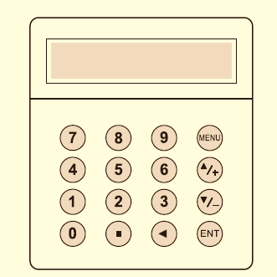
0 - 9 and . are used for inputting numbers or menu numbers.
◄ is used for back left or delete the left character.
▲/+ and ▼/- are used for entering into the last and next menu. Also can be used as ± sign when inputting numbers.
MENU is used for accessing the menu. Press this key first, then type the number keys to enter into the matched menu.
ENT is the ENTER key, used for confirming the contents you input or choose.

Keyboard - VIR-832-M

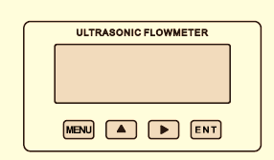

VIR-832-M
- MENU: used for entering into menus.
- ▲: used for menu up or choosing 0-9, +, -
- : used for menu down or moving the cursor to next.
- ENT: used for finishing menu inputting or entering into submenu.

Operation:

The user interface of this flow meter comprises about 100 different menu windows that are numbered by M00, M01, M02 … M99.

Method to enter Menu: Press MENU first and follow the two-digit number keys. Take M35 as an example, the correct key sequence is MENU35

To move between the adjacent menus, press ▲/+ and ▼/- for 16-key keyboard; press ▲and for 4-key keyboard.

Menu Details

Quick setup of measured parameters

Accurate measured parameters can have a great influence on measuring precision and reliability. It is suggested to measure the practical perimeter and wall thickness of the pipeline. Ultrasonic thickness gauge can be used to measure the pipe thickness.

Measured parameters setup is from Menu10 to Menu29. Please complete one by one.

Above parameters setup generally follow the steps below:
- Press keys MENU 1 1 to enter M11 window to input the pipe outer diameter, and then press

ENT key.
- Press key ▼/- to enter M12 window to input the pipe outer diameter and then press ENT key.
- Press key ▼/- to enter M14 window, and press ENT key to enter the option selection mode.

Use keys ▲/+ and ▼/- to select the pipe material, and then press ENT key.
- Press key ▼/- to enter M16 window, press ENT key to enter the option selection mode. Use
- keys ▲/+ and ▼/- to select the liner material, and then press ENT key. Select “No Liner”, if there is no liner.
- Press key ▼/- to enter M20 window, press ENT key to enter the option selection mode. Use
- keys ▲/+ and ▼/- to select the proper liquid, and then press ENT key.
- Press key ▼/- to enter M23 window, press ENT key to enter the option selection mode. Use keys ▲/+ and ▼/- to select the proper transducer type, and then press ENT key.
- Press key ▼/- to enter M24 window, press ENT key to enter the option selection mode. Use

keys ▲/+ and▼/- to select the proper transducer mounting method, and then press ENT key.
- Press key ▼/- to enter M25 window and get the transducer installation distance.
- Press MENU 2 6 to store the parameters setup.

Choose installation points

Proper installation point is a key for transducer installation. Following factors must be considered: Full filled pipeline, shaking, steady flow, scaling, temperature, pressure, EMI, instrument well.

Full filled pipeline

Following situations can be full filled of liquid:

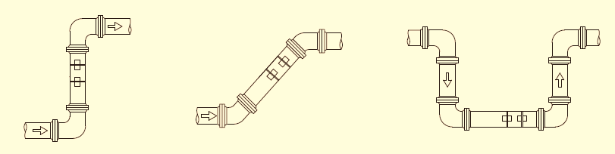

Vertical upward Obliquely upward Lowest point

Vibration

There cannot be obvious vibration on the installation point, otherwise it needs to be tightened.

Steady flow

Steady flow is helpful for ensuring measurement accuracy.

Standard requests for steady flow are:
- The pipe should be far away from pump outlet and half-open valve.
- 10D to upstream and 5D to downstream. (D means outer diameter)
- 30D to pump outlet and half-open valve.

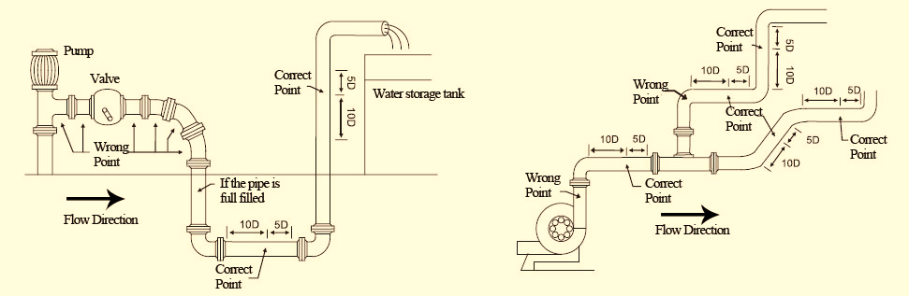

Scaling

The inside scaling would have bad effect on ultrasonic signal transmission and would decrease the inner diameter as well. As a result, the measurement accuracy cannot be guaranteed. Please try to avoid choosing the installation point with inside scaling.

Temperature

The liquid temperature on installation point should be in the working range of transducers. Please try to choose the point with lower temperature. Avoid choosing points like the outlet of boiler water and heat exchanger. Return water pipe would be better.

Temperature range of standard clamp on and insertion transducers: -30 ~ 90℃

Temperature range of high temperature clamp on and insertion transducers: -30 ~ 160℃

Pressure

The maximum pressure for standard insertion and inline transducer is 1.6MPa

Out of this range need customized.

Configuration Steps:
- Press the relevant key to access Menu10, input the pipe’s outer diameter, and confirm with the [ENT] key.
- Navigate to Menu12 to input the pipe wall thickness, then press [ENT] to confirm.
- Proceed to Menu14, press [ENT] to enter selection mode, use the arrow keys to choose the pipe material, and confirm your choice.
- In Menu16, enter selection mode with [ENT], use arrow keys to select liner material, and press [ENT] to confirm. If there is no liner, select "No Liner."
- Access Menu20, enter selection mode with [ENT], use arrow keys to select the type of liquid, and confirm your choice.
- Go to Menu23, enter selection mode with [ENT], use arrow keys to select the appropriate transducer type, and press [ENT] to confirm.
- Enter Menu24, enter selection mode with [ENT], use arrow keys to choose the transducer mounting method, and confirm your selection.
- Move to Menu25 to obtain the required transducer installation distance.
- Finally, press [WW] to save all parameter settings.

Additional Considerations for Installation
Scaling:
- Internal scaling can negatively affect ultrasonic signal transmission and significantly reduce measurement accuracy. If scaling is present at the installation point, reliable measurement cannot be guaranteed.
Temperature:
- Ensure that the liquid temperature at the installation site is within the working range of the selected transducers. opt for locations with lower temperatures whenever possible—avoid areas such as boiler or heat exchanger outlets. Return water pipes are generally preferable.
- Standard clamp-on and insertion transducers: -30°C to 90°C
- High-temperature clamp-on and insertion transducers: -30°C to 160°C
Pressure:
- The maximum pressure for standard insertion and inline transducers is 1.6 MPa. For applications outside this range, custom solutions are required.
Electromagnetic Interference (EMI):
Ultrasonic flow meters, along with their transducers and signal cables, are susceptible to interference from sources such as frequency converters, radio stations, microwave transmitters, GSM base stations, and high-voltage cables. To minimize EMI. Avoid installing equipment near these sources. Connect the shield layer of the flow meter, transducer, and signal cable to the earth. Use an isolated power supply. Do not share a power supply with frequency converters.

Mounting Dimension:
VIR-832

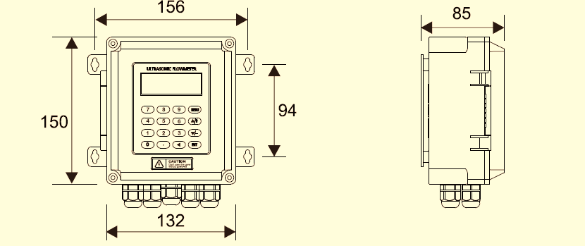

Wiring Details:

VIR-832
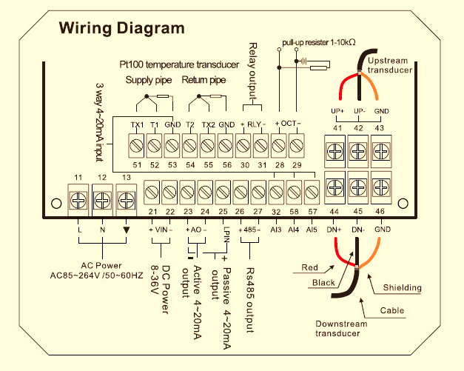

Power Supply: 230V AC- UPS stable power
- Load: 5Amps Max
- Installation: Indoor
- Protection: IP-65
- Cable: Use 1.5sqmm cable, Screened and Twisted Pair
- Communication: Modbus RTU

Mounting Dimension: VIR-832

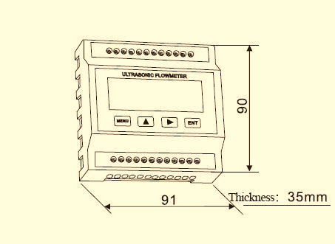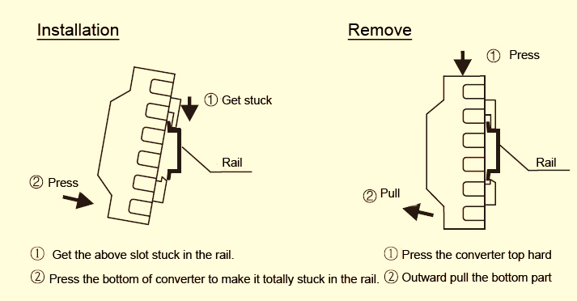

Wiring Details: VIR-832

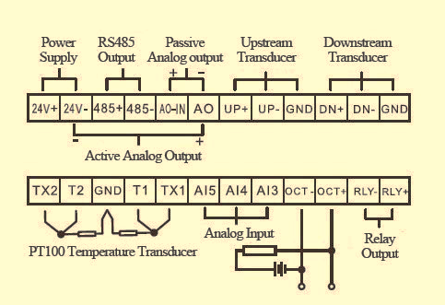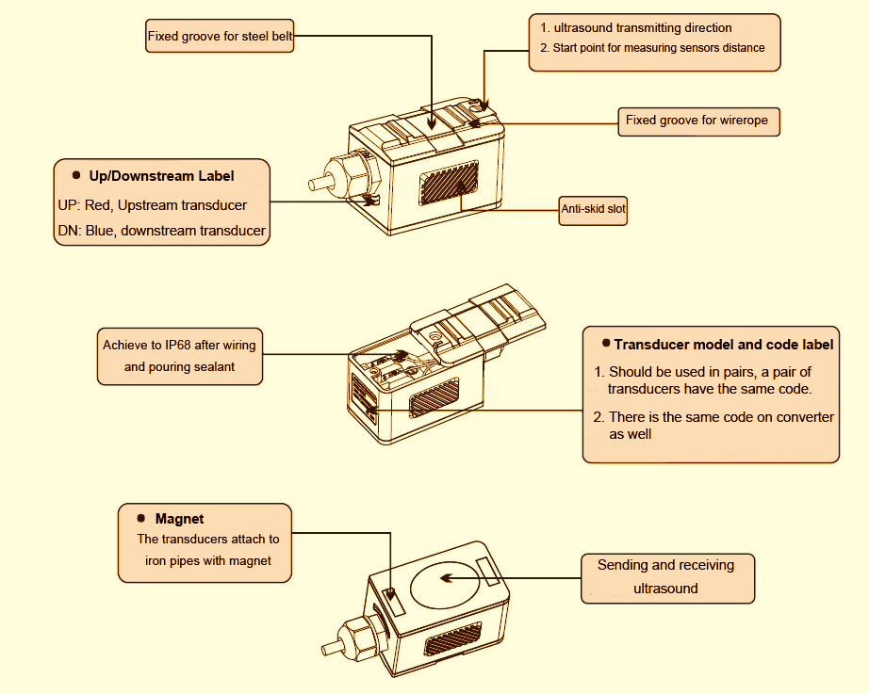

Clamp – On Flow Detector Wiring:

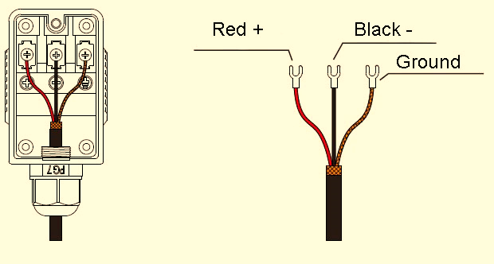

Insertion Transducer Details:

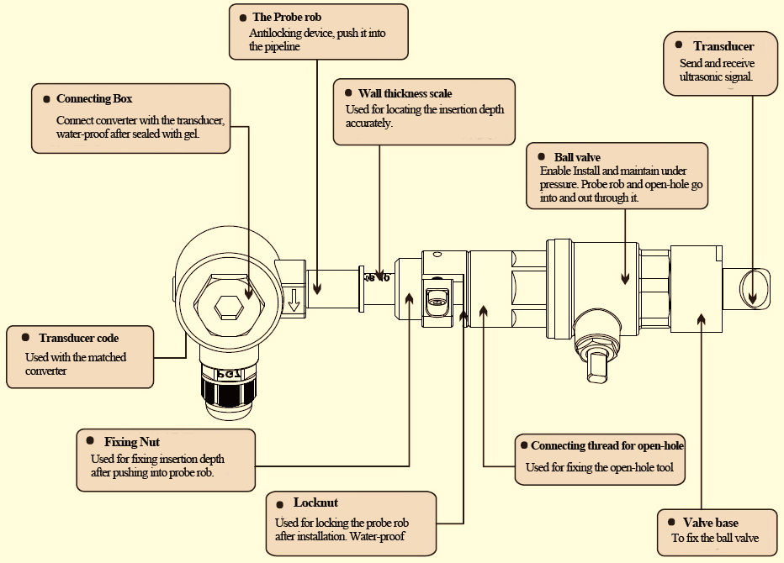

Wiring:

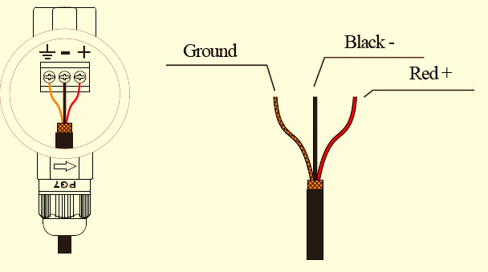

Parameters &Menu Details:
Menu No. |  | Function
M00 |  | Display flow rate and NET totalizer.
 |  | If the net totalizer is turned off (refer to M34), the net totalizer value shown on the screen is the value prior to its turn off.
 |  | Select all totalizer unit in menu M31.
M01 |  | Display flow rate, velocity.
M02 |  | Display flow rate and POS (positive) totalizer.
 |  | If the positive totalizer is turned off, the positive totalizer value shown on the screen is the value prior to its turn off.
M03 |  | Display flow rate and NEG (negative) totalizer.
 |  | If the negative totalizer is turned off, the negative totalizer value shown on the screen is the value prior to its turn off.
M04 |  | Display date and time, flow rate. The date and time setting method is found in MENU60.
M05 |  | Display energy rate (instantaneous Caloric) and total energy (Caloric).
M06 |  | Display temperatures, inlet T1, outlet T2.
M07 |  | Display analogue inputs, AI3/AI4, current value and its corresponding temperature or pressure or liquid level value.
M08 |  | Display all the detailed error codes.
 |  | Display working condition and system error codes. ‘R’ stands for normal; others refer to Chapter 5 for details.
M09 |  | Display today’s total NET flow.
M10 |  | Window for entering the outer perimeter of the pipe.
 |  | If pipe outer diameter is known, skip this menu and go to Menu 11to enter the outer diameter.
M11 |  | Window for entering the outer diameter of the pipe. Valid range:0 to 18000mm.
 |  | Note: you just need to enter either the outer diameter in M11 or the perimeter in M10.
M12 |  | Window for entering pipe wall thickness
 |  | You may skip the menu and enter inner diameter in M13 instead.
M13 |  | Window for entering the inner diameter of the pipe
 |  | If pipe outer diameter and wall thickness are entered correctly, the inner diameter will be calculated automatically, thus no need to change anything in the window
M14 |  | Window for selecting pipe material
 |  | Standard pipe materials (No need to enter material sound speed) include:
 |  | (0) carbon steel (1) stainless steel (2) cast iron (3) ductile iron (4) copper (5) PVC (6) aluminium ,(7) asbestos (8) fiberglass
 |  | (9) other( need to enter material sound speed in M15)
M15 |  | Window for entering the pipe material speed, only for non-standard pipe materials
M16 |  | Window for selecting the liner material, select none for pipes without any liner.
 |  | Standard liner materials(no need to enter the liner sound speed) include:
 |  | (0) None, No liner (1) Tar Epoxy (2) Rubber (3) Mortar (4) Polypropylene (5) Polystyle (6)Polystyrene (7) Polyester (8) Polyethylene (9) Ebonite (10) Teflon
 |  | (11) Other (need to enter liner sound speed in M17)
M17 |  | Window for entering the non-standard liner material speed.
M18 |  | Window for entering the liner thickness, if there is a liner
M19 |  | Window for entering the ABS thickness of the inside wall of the pipe
M20 |  | Window for selecting fluid type
 |  | For standard liquids(no need to enter fluid sound speed) include:
 |  | (0) Water (1) Sea Water (2) Kerosene (3) Gasoline (4) Fuel oil (5) Crude Oil
 |  | (6) Propane at -45C (7) Butane at 0C
 |  | (8)Other liquids(need to enter sound speed in M21 and viscosity in M22)
 |  | (9) Diesel Oil (10)Caster Oil (11)Peanut Oil (12) #90 Gasoline (13) #93 Gasoline (14) Alcohol (15) Hot water at 125C
M21 |  | Window for entering the sound speed of non- standard liquid, used only when option item 8 ‘Other’ is selected in M20
M22 |  | Window for entering the viscosity of the non-standard liquids, used only when option item 8 ‘Other’ is selected in M20
M23 |  | Window for selecting transducer type, There are 22 types as following
 |  | 0. Standard-M (The middle size) 1. Insertion Type C
 |  | 2. Standard-S 3. User Type 4. Standard B
 |  | 5. Insertion Type B(45) 6. Standard-L (The large size transducers)
 |  | 7. JH-Polyconics 8. Standard-HS (small size transducer for TUF-2000H
 |  | 9. Standard-HM (middle size transducer for Handheld flow meter)
 |  | 10. Standard-M1 (middle size transducer #1)
 |  | 11. Standard-S1 (small size transducer #1)
 |  | 12. Standard-L1 (large size transducer #1)
 |  | 13. PI-Type 14. FS410 (middle size transducer for FUJI flow meter)
 |  | 15. FS510 (large size transducer for FUJI flow meter)
 |  | 16. Clamp-on TM-1 (Middle size transducer for Taosonics Instrument)
 |  | 17. Insertion TC-1 (for Virtec)
 |  | 18. Clamp-on TS-1 (small size for Taosonics Instrument)
 |  | 19. Clamp-on TS-1 20. Clamp-on TL-1 (For Virtec)
 |  | 21. Insertion TLC-2 (For Virtec)
 |  | 22. Clamp-on M2 23. Clamp-on L2
 |  | If the user-type-transducer is selected, you need enter additional 4 user-type-wedge parameters that describe the user transducers.
 |  | If the PI-type transducer is selected, you need enter additional 4 PI-type transducer parameters that describe the PI-type transducers
M24 |  | Window for selecting the transducer mounting methods
 |  | Four methods can be selected:
 |  | (0) V-method (1) Z-method (2) N-method (3) W-method
M25 |  | Display the transducer mounting spacing or distance
M26 | (1) A switch for the parameters in flash memory will be loaded when power is turned on. The default option is that the parameters will be loaded. If this switch is not turned on, the system will try to use the parameters in the system RAM, if these parameters are ok, otherwise the system will load the parameters in flash memory
M26 | (2) Function to store the current parameters into the flash memory, so that these parameters will be solidified and will be loaded as the default parameters every time when power is turned on.
M27 | Entry to store to or restore from the internal Flash memory, as many as 9 different pipe parameter configurations
M27 | To save or load the current setup parameter, use the going up or going down keys to change the address number, press ‘ENT’ key, and use going down or going up keys to select to save to or load from the memory.
M28 | Entry to determine whether or not to hold (or to keep) the last good value when poor signal condition occurs. YES is the default setup.
M29 | Entry to setup empty signal threshold. When the signal is less than this threshold, the pipe is regarded as empty pipe, and the flow meter will not totalize flow.
M29 | This is based on the fact that, for most occasions, when pipe is empty, the transducer would still receive signal, just smaller than normal, As a result, The flow meter would show normal operation, which is not correct.
M29 | Make sure that the entered value must be less than the normal signal strength.
M29 | When much noisy signals are received, to make sure the flow meter will not incorrectly totalize flow, there is also a ‘Q’ threshold should be entered in M.5
M30 | Window for selecting unit system. The conversion English to Metric or vice versa will not affect the unit for totalizers.
M31 | Window for selecting flow rate unit system.
M31 | Flow rate can be in
M31 | 0. Cubic meter short for (m3)
M31 | 1. Liter (l)
M31 | 2. USA gallon (gal)
M31 | 3. Imperial Gallon (igl)
M31 | 4. Million USA gallon (mgl)
M31 | 5. Cubic feet (cf)
M31 | 6. USA liquid barrel (bal)
M31 | 7. Oil barrel (ob)
M31 | The flow unit in terms of time can be per day, per hour, per minute or per second. So, there are 32 different flow rate units in total for selection.
M32 | Window for selecting the totalizers unit. Available units are the same as those in M31
M33 | Window for setting the totalizer multiplying factor
M33 | The multiplying factor ranges from 0.001 to 10000. Factory default is 1
M34 | Turn on or turn off the NET totalizer
M35 | Turn on or turn off the POS (positive) totalizer
M36 | Turn on or turn off the NEG (negative) totalizer
M37 | (1) Totalizer reset
M37 | (2) Restore the factory default settings parameters. Press the dot key followed by the backspace key. Attention, it is recommended to make note on the parameters before doing the restoration
M38 | Manual totalizer used for easier calibration. Press a key to start and press a key to stop the manual totalizer.
M39 | Language selection.
M39 | The selection could also be changed automatically by the system, if English LCD display is used as the display device.
M3A | Setup for local segmental LCD display. Enter 0 or 1 for the non-auto-scan mode; Enter 2~39 for the auto-scan mode. In the auto-scan mode the display will automatically scan displaying from 00 to the entered number of the local segmental LCD display.
M40 | Flow rate damper for a stable value. The damping parameter ranges from 0 to 999 seconds.
M40 | 0 means there is no damping. Factory default is 10 seconds
M41 | Low flow rate (or zero flow rate) cut-off to avoid invalid accumulation.
M42 | Zero calibration/Zero-point setup. Make sure the liquid in the pipe is not running while doing the setup.
M43 | Clear the zero point value and restore the solidified zero-point value.
M44 | Set up a flow bias. Generally, this value should be 0.
M45 | Flow rate scale factor. The default value is ‘1’.
M45 | Keep this value as ‘1’, when no calibration has been made.
M46 | Networks address identification number. Any integer can be entered except 13(0DH, carriage return), 10 (0AH, line feeding), 42 (2AH), 38, 65535.
M46 | Every set of the instrument in a network environment should have a unique IDN. Please refer to the chapter for communication.
M47 | System locker to avoid modification of the system parameters.
M47 | If password is forgotten, you could send a command ‘LOCK0’ to the serial input to unlock. Or you can write 0 to REGISTER49-50 under MODBUS protocol.
M48 | Entry to linearity correcting data inputs. By using of this function, the non-linearity of flow meter will be corrected. Correcting data shall be obtained by careful calibration.
M49 | Displays the input contents for the serial port.
M49 | By checking the displays, you can know if the communication is ok.
M50 | Switches for the built-in data logger. There are as many as 22 different items can be chosen. To turn this function, select ‘YES’ the system will ask for selecting the items. There are 22 items available. Turn on all those items you want to output
M51 | Window to setup the time of scheduled output function (data logger, or Thermo-printer). This includes start time, time interval and how many times of output. When a number great than 8000 entered for the times of output, it means the output will be keeping always. The minimum time interval is 1 second and the maximum is 24 hours.
M52 | Data logging direction control.
M52 | (1) If ‘Send to RS485’ is selected, all the data produced by the data logger will be transmitted out through the RS-232/RS485 interface
M52 | (2) If ‘To the internal serial BUS is selected, the data will be transmitted to the internal serial bus which allows a thermal printer, or a 4-20mA analogue output module, to be connected to it.
M53 | Display antilog inputs, AI5, current value and its corresponding temperature or pressure or liquid level value.
M54 | Pulse width setup for the OCT (OCT1) output. Minimum is 6 mS, maximum is 1000 mS
M55 | Select analogue output (4-20mA current loop, or CL) mode. Available options:
M55 | (0) 4-20mA output mode (setup the output ranges from 4-20mA)
M55 | (1) 0-20mA output mode (setup the output ranges from 0-20mA, this mode can only be used with Version-15 flow meter)
M55 | (2) RS232 Serial port controls 0-20mA
M55 | (3) 4-20mA corresponding fluid sound speed
M55 | (4) 20-4-20mA mode
M55 | (5) 0-4-20mA mode (can only be used with Version-15 flow meter)
M55 | (6)20-0-20mA mode (can only be used with Version-15 flow meter)
M55 | (7) 4-20mA corresponding flow velocity
M55 | (8)4-20mA corresponding heat flow rate
M56 | 4mA or 0mA output value,
M56 | Set the value which corresponds to 4mA or 0mA output current (4mA or 0mA is determined by the setting in M55)
M57 | 20mA output value,
M57 | Set the value which corresponds to 20mA output current
M58 | Current loop verification
M58 | Check if the current loop is calibrated correctly.
M59 | Display the present output of current loop circuit.
M60 | Setup system date and time. Press ENT for modification. Use the dot key to skip the digits that need no modification.
M61 | Display Version information and Electronic Serial Number (ESN) that is unique for each flow meter.
M61 | The users may employ the ESN for instrumentation management
M62 | RS-232/RS485 setup. All the devices connected with flow meter should have matched serial configuration.
M62 | The following parameters can be configured: Baud rate (300 to 19200 bps), parity, data bits (always is 8), stop bits (1).
M63 | Select communication protocol.
M63 | Factory default is ‘MODBUS ASCII. this is a mode for MODBUS-ASCII, Meter-BUS, Fuji Extended Protocol, Huizhong’s various protocols.
M63 | If you are going using MODBUS-RTU you have to select ‘MODBUS_RTU’.
M64 | AI3 value range.
M64 | Used to enter temperature/pressure values that are corresponding to 4mA and 20mA input current. The display values have no unit, so that they can present any physical parameter.
M65 | AI4 value range.
M65 | Used to enter temperature/pressure values that are corresponding to 4mA and 20mA input current.
M66 | AI5 value range.
M66 | Used to enter temperature/pressure values that are corresponding to 4mA and 20mA input current.
M67 | Windows to setup the frequency range (lower and upper limit) for the frequency output function. Valid range is 0Hz-9999Hz. Factory default value is 0-1000 Hz.
M67 | For Version-12, Version-13, Version-14 flow meters, you need a hardware module, which shall be plugged to the Serial Expanding Bus, for the frequency output function. Please remember to order the module if you need frequency output function.
M67 | For Version-15 flow meter, you need to indicate on your orders that you need the frequency function; Otherwise, you will get a flow meter which has no frequency output circuits.
M68 | Window to setup the minimum flow rate value which corresponds to the lower frequency limit of the frequency output.
M69 | Windows to setup the maximum flow Rate value that corresponds to the upper frequency limit of the frequency output.
M70 | LCD display backlight control. The entered value indicates how many seconds the backlight will be on with every key pressing. If the enter value is great than 50000 seconds, it means that the backlight will always keeping on.
M71 | LCD contrast control. The LCD will become darker or brighter when a value is entered.
M72 | Working timer. It can be cleared by pressing ENT key, and then select YES.
M73 | Window to setup the lower limit of flow rate for Alarm#1.
M73 | When the flow rate is below the set value, Alarm#1 equals ‘on’
M74 | Window to setup the upper limit of flow rate for Alarm#1.
M74 | When the flow rate is above the set value, Alarm#1 equals ‘on’
M74 | There are two alarms in the flow meter, and every alarm can be pointed to alarm output devices such as the BUZZER or OCT output or RELAY output. For example, if you want the Alarm#1 is to output by the OCT circuit, you need to set M78 at selection item 6.
M75 | Window to setup the lower limit of flow rate for Alarm#2.
M76 | Window to setup the upper limit of flow rate for Alarm#2.
M77 | Buzzer setup.
M77 | If a proper input source is selected, the buzzer will beep when the trigger event occurs. The available trigger sources are:
M77 | 0. No Signal 1. Poor Signal
M77 | 2. Not Ready (No*R) 3. Reverse Flow 4. AO Over 100%
M77 | 5. FO Over 120% 6. Alarm #1 7. Reverse Alarm #2
M77 | 8. Batch Controller 9. POS Int Pulse 10.NEG Int Pulse
M77 | 11.NET Int Pulse 12. Energy POS Pulse 13. Energy NEG Pulse
M77 | 14.Energy NET Pulse 15. MediaVel=>Thresh 16.MediaVelo<Thresh
M77 | 17.ON/OFF viaRS485 18. Daily Timer (M51) 19.Timed alarm #1
M77 | 20. Timed alarm #2 21. Batch Total Full 22. Timer by M51
M77 | 23. Batch 90% Full 24. Key Stroking ON 24.Disable BEEPER
M78 | OCT (Open Collect Transistor Output)/OCT1 setup
M78 | By selecting a proper input source, the OCT circuit will close when the trigger event occurs. The available trigger sources are:
M78 | 0. No Signal 1. Poor Signal
M78 | 2. Not Ready(No*R) 3. Reverse Flow
M78 | 4. AO Over 100% 5. FO Over 120%
M78 | 6. Alarm #1 7. Reverse Alarm #2
M78 | 8. Batch Controller 9. POS Int Pulse
M78 | 10.NEG Int Pulse 11.NET Int Pulse
M78 | 12.Energy POS Pulse 13.Energy NEG Pulse
M78 | 14.Energy NET Pulse 15.MediaVel=>Thresh
M78 | 16.MediaVelo<Thresh 17.ON/OFF viaRS485
M78 | 18. Daily Timer (M51) 19.Timed alarm #1
M78 | 20. Timed alarm #2 21.Batch Total Full 22.Timer by M51
M78 | 23.Batch 90% Full 24.Flow Rate Pulse 25.Disable OCT
M78 | The OCT circuit does not source voltage at its output. It must be connected with an external power and pull-up resistant for some occasions.
M78 | When the OCT circuit is close, it will draw current. The maximum current shall not be over 100mA.
M78 | Attention: the maximum voltage applied to OCT can not be over 80 volts.
M79 | Relay or OCT2 setup
M79 | By selecting a proper input source, the RELAY will close when the trigger event occurs
M79 | The available trigger sources are:
M79 | 0. No Signal 1. Poor Signal
M79 | 2. Not Ready(No*R) 3. Reverse Flow 4. AO Over 100%
M79 | 5. FO Over 120% 6. Alarm #1 7. Reverse Alarm #2
M79 | 8. Batch Controller 9. POS Int Pulse 10.NEG Int Pulse
M79 | 11.NET Int Pulse 12.Energy POS Pulse
M79 | 13.Energy NEG Pulse 14.Energy NET Pulse
M79 | 15.MediaVel=>Thresh 16.MediaVelo<Thresh
M79 | 17.ON/OFF viaRS485 18. Timer (M51 Daily)
M79 | 19.Timed alarm #1 20. Timed alarm #2
M79 | 21.Batch Total Full 22.Timer by M51
M79 | 23.Batch 90% Full 24.Disable RELAY
M79 | The RELAY is of SPST(Single pole, single throw) type. It is rated for 110VAC max and have a current rating of 0.5A resistive load.
M79 | It highly recommended that a salve relay to be utilized whenever a large resistive load or inductive load is to be controlled.
M79 | Note. In order to make the user interface compatible with the former version7, the name RELAY was used other than OCT2, but in fact it is an OCT output.
M80 | Window for selecting the trigger signal for the built-in batch controller. Available trig sources:
M80 | 0. Key input (press ENT key to start the batch controller)
M80 | 1. Serial port
M80 | 2. AI3 rising edge (when AI3 receives 2mA or more current)
M80 | 3. AI3 falling edge (when AI3 stop receiving 2mA or more current)
M80 | 4. AI4 rising edge (when AI3 receives 2mA or more current)
M80 | 5. AI4 falling edge (when AI3 stop receiving 2mA or more current)
M80 | 6. AI5 rising edge (when AI3 receives 2mA or more current)
M80 | 7. AI5 falling edge (when AI3 stop receiving 2mA or more current)
M80 | 8.Timer periodically (define the start time and interval time in M51)
M80 | 9.Timer daily (define the start time and interval time in M51)
M80 | For the input analogue current signal, 0 mA indicates “0”, 4mA or more indicates ‘1’.
M80 | By selecting item #8, the batch totalizer can be started periodically by the internal timer located at Menu51. When the batch totalizer is full, a signal which indicate the batch is full can be direct to either the OCT or the RELAY terminals to stop the pump or other devices.
M80 | By selecting item #9, the batch totalizer could act as totalizer witch runs for only a period of the day so that a alarm signal could be produced if the total flow during that time period is over a certain amount of. For example, if you want a alarm signal which stand for the total flow is over 100 cubic meters during the period of every day from 20:00 to 06:00, setups is like
M80 | M51 start time =20:00:00
M80 | M51 interval =10:00:00
M80 | M51 log times =9999 (means always)
M80 | M80 select item #9
M80 | M81 input 100 (Unit is defined in M30,M31,M32)
M81 | The built-in batch controller
M81 | Set the flow batch value(dose)
M81 | The internal output of the batch controller can be directed either to the OCT or the RELAY output circuits.
M81 | M81 and M80 should be used together to configure the batch controller.
M81 | Note: Because the measuring period is 500mS, the flow for every dos should be keeping at 60 seconds long to get a 1% dose accuracy.
M82 | View the daily, monthly and yearly flow totalizer and thermal energy totalizer value.
M82 | The totalizer values and errors for the last 64 days, 32 last 32 months and last 2 years are stored in the RAM memory, To view them, use the ‘ENT’ and ‘UP’ ‘Down’ keys.
M83 | Automatic Amending Function for automatic offline compensation.
M83 | Select ‘YES’ to enable this function, select ‘NO’ to disable it.
M83 | When the function is enabled, The flow meter will estimate the average flow uncounted (or ‘lost’) during the offline session and add the result to the totalizer.
M83 | The estimation of the uncounted flow is made by computing the product of the offline time period and the average flow rate, which is the average of the flow rate before going offline and the one after going on line.
M84 | Set the thermal energy unit:
M84 | 0. GJ 1. KC 2.KWh 3. BTU
M85 | Select temperature sources
M85 | 0. from T1,T2 (factory default)
M85 | 1. from AI3,AI4
M86 | Select the Specific Heat Value.
M86 | Factory default is ‘GB’. Under this setting, the flow meter will calculate the enthalpy of water based on the international standard.
M86 | If the fluid is other than water, you should select option ‘1. Fixed Specific Heat’, and enter the specific heat value of the fluid.
M87 | Turn on or turn off the Energy totalizer.
M88 | Select thermal energy totalizer multiplying factor.
M88 | Factory default is ‘1’.
M89 | 1. Display the temperature difference
M89 | 2. Window for entering the lowest temperature difference.
M8. | Heat meter is on
M8. | 1. Inlet
M8. | 2. Outlet
M8. | Select the heat meter installation place.
M90 | Display signal strengths S (one for upstream and one for downstream), and signal quality Q value.
M90 | Signal strength is presented by 00.0 to 99.9, the bigger the value, the bigger the signal strength will be, and more reliable readings will be made.
M90 | Q value is presented by 00 to 99, the bigger the better. It should at least be great than 50 for normal operations.
M91 | Displays the Time Ratio between the Measured Total Transit Time and the Calculated time. If the pipe parameters are entered correctly and the transducers are properly installed, the ratio value should be in the range of 100±3%. Otherwise the entered parameters and the transducer installation should be checked.
M92 | Displays the estimated fluid sound velocity. If this value has an obvious difference with the actual fluid sound speed, pipe parameters entered and the transducer installation should be checked again.
M93 | Displays total transit time and delta time(transit time difference)
M94 | Displays the Reynolds number and the pipe factor used by the flow rate measurement program. Pipe factor is calculated based on the ratio of the line-average velocity and the cross-section average velocity.
M95 | (1) Display the positive and negative energy totalizers
M95 | (2) Upon entering this window, the circular display function will be started automatically. The following windows will be displayed one by one, each window will stay for 8 seconds: M95>>M00>>M01>>M02>>M02>> M03>>M04>>M05>>M06>>M07>>M08>>M90>>M91>>M92>> M93>> M94>>M95. This function allows the user to visit all the important information without any manual action.
M95 | To stop this function, simply press a key. Or switch to a window other than M95.
M96 | This is not a window but a command for the thermal printer to advance 5 lines of paper.
M97 | This is not a window but a command to print the pipe parameters.
M97 | By default, the produced data will be directed to the internal serial bus (thermal printer). You can also direct those data to the serial communication port.
M98 | This is not a window but a command to print the diagnostic information.
M98 | By default, the produced data will be directed to the internal serial bus (thermal printer). You can also direct those data to the serial communication port.
M99 | This is not a window but a command to copy the current display window. By default, the produced data will be directed to the internal serial bus (thermal printer). You can also direct those data to the serial communication port.
M99 | By use of the window copying function, you can hardcopy very window displaying manually by switching windows, or you can obtain the window displaying data by communication.
M+0 | Browse the 32 recorded instrument power-on and power-off date and time with the flow rate at the time of power on and off
M+1 | Displays the total working time of the flow meter.
M+1 | When the backup battery is removed, the total working time will be reset to zero.
M+2 | Displays the last power-off date and time
M+3 | Displays the last power-off flow rate
M+4 | Displays how many times of has been powered on and powered off.
M+5 | A scientific calculator for the convenience of field working.
M+5 | All the values are in single accuracy.
M+5 | The calculator can be used while the flow meter is conducting flow measurement.
M+5 | Water density and PT100 temperature can also be found in this function.
M+6 | Set fluid sound speed threshold
M+6 | Whenever the estimated sound speed (displayed in M92) exceeds this threshold, an alarms signal will be generated and can transmitted to BUZZER or OCT or RELAY.
M+6 | This function can used to produce an alarm or output when fluid material changes.
M+7 | Displays total flow for this month(only for the time past)
M+8 | Displays total flow for this year(only for the time past)
M+9 | Display the not-working total time in seconds. The total failure timer will also include the time when power off, if the back-up battery is applied.
M.2 | Entry to solidify the zero point. Password protected.
M.5 | Setup the Q value threshold.
M.5 | If the present Q is below this threshold, flow rate will be set to 0.
M.5 | This function is useful when flow meter is installed in noisy environment or on airy pipes.
M.8 | The maximum flow rates for today and this month.
M.9 | Serial port tester with CMM command output for very second.
M-0 | Entry to hardware adjusting windows only for the manufacturer
M-1 | 4-20mA output adjustment
M-2 | 4mA calibration for AI3 input
M-3 | 20mA calibration for AI3 input
M-4 | 4mA calibration for AI4 input
M-5 | 20mA calibration for AI4 input
M-6 | 4mA calibration for AI5 input
M-7 | 20mA calibration for AI5 input
M-8 | Lower Temperature Zero setup for the PT100
M-9 | Higher Temperature Zero setup for the PT100
M-A | Temperature Calibration at 50℃
M-B | Temperature Calibration at 84.5℃

Current Loop and Analog Output Calibration
For precise output, the flow meter comes equipped with a 4~20mA current loop, offering accuracy within 0.5%. The system allows for easy programming and supports various output modules, including 4~20mA. To configure these settings, navigate to the "Setup Menu - Input and Output Setting."
Within this menu, you can calibrate the flow values corresponding to 4mA and 20mA. For example:
- If the flow measurement range is 0 to 1000 m³/h, enter 0 for 4mA and 1000 for 20mA.
- For a range of -1000 to 2000 m³/h, configure the module to cover the full flow direction by inputting -1000 and 2000.
Analog Output Calibration:
Each flow meter undergoes strict calibration before leaving the factory, so further adjustment is generally unnecessary. However, if the actual output current value does not match the value displayed in the "Setup Menu - Input and Output Setting" during calibration, recalibration may be required.

VIRTEC INSTRUMENTS – FLOW METER MANUAL
🔚 END OF MANUAL

✅ Product Support & Warranty
Virtec Instruments assures that all flow meters are manufactured with the highest standards of quality and precision. For warranty details, service support, and installation queries, please refer to the Warranty Certificate provided or contact our authorized service center.
Warranty Coverage: 2 years from the date of Supply against following:
- Manufacturing defects
- Sensor malfunctions
- Electronics issues (as per model specifications)
Warranty does not cover:
- Physical damage
- Improper installation
- Tampering with seal or calibration

🛠 Technical Support
If you require assistance, please reach out to:
Virtec Instruments INC.
Salt Lake City, Utah, USA
📞 +1 3045194567
📧 sales@virtec.us
🌐 www.virtec.us

📌 Note to Installer / User
Please ensure that:
- All installation steps were followed as per guidelines.
- Calibration and commissioning have been documented.
- Maintenance schedule is noted for future checks.

📝 Service Log (For User Use)
Date | Service Description | Technician Name & Sign | Remarks

📄 Document Control
Document Title: Flow Meter Installation & Operation Manual
Document No.: VIR-FM-UM-2021
Revision: R2.0 Last Updated: July 2024

